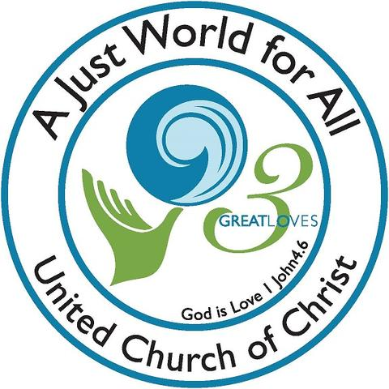Blessed Advent Season to All

1 John 4:7 ⁷ Dear friends, let us love one another, for love comes from God. Everyone who loves has been born of God and knows God. Pema Chodron discusses this issue and says, “Every morning you could ask yourself, ‘As I go into this day, what is the most important thing? What is the best use of this day?’ At my age it’s kind of scary when I go to bed at night and I look back at the day, and it seems like it passed in the snap of a finger. That was a whole day? What did I do with it? Did I move any closer to being more compassionate, loving and caring—to being fully awake? Is my mind more open? What did I actually do? I feel how little time there is and how important it is how we spend our time.”
In this season of hope, of generosity, the UCC has a new campaign of story, and you can make it a part of your day or days! We have so many compassionate stories in our small town of Mason, acts here in Mason and in the wider world. Watch, listen, and share! Think of ways we could share our abundance with the victims of California fires or the continuing struggle in Syria that is leaving so many women and children especially without hope. In NH there is: https://www.ascentria.org/our-services/services-for-new-americans to help new refugees.
From UCC: “We all have a story. We are all a part of God’s story. What’s your story?
Three Great Loves is our denomination-wide story-telling initiative. In the coming years, the United Church of Christ will collect and lift up the stories of our local churches and affiliates – stories about how we are living out God’s love and expressing love of neighbor, children, and creation (our Three Great Loves). From making hats for newborns to collecting food for food pantries, to standing together against a social injustice – no story is too insignificant to share.
The hope of this initiative is to tell and share the stories of how individuals, churches, and organizations of the UCC are impacting and transforming the world as covenantal partners united in our common purpose, vision, and mission. This work lives out the love of God and leads to creating a just world for all. Read more: http://www.ucc.org/3greatloves or write to: Three Great Loves, United Church of Christ, 700 Prospect Ave, Cleveland, OH 44115”
How wonderful to read and listen to stories that are not doom and gloom, and that illustrate the goodness that can be in people. This is what we need to hear over and over, this is the “news” that needs repeating!
Upcoming Events
- December 1 Saturday at 9-11 am Come help decorate our church home in readiness for the Season of Advent. We will dust off the wreaths, change the candles, put up the advent wreath, decorate our sanctuary Christmas tree, and so much more.

- December 1 Library Storytelling and crafts from 3:30 to 4:30 Followed by Santa’s arrival at 5 pm, and the Lighting of the Town Christmas Tree.
- December 2, beginning of four Sundays of Advent. To celebrate this season of waiting, we invite people to share a story of compassion and love within our own community or the wider community after the advent lighting each Sunday. Speak to Rev Veronica, or one of the Deacons if you want to share. Worship at 10 am. Childcare available.
- December 8 Nashua Soup Kitchen. Meet in the church parking lot at 3:30 for carpooling to Nashua. We are usually back by 6:30 or 7pm. Share your love and energy in this outreach mission of our community. Contact Kathy Chapman if you plan to go or need information 603-878-4993 or email chapman.kathy@gmail.com
- December 16, 2018 11:30 to 1 pm Christmas Community Luncheon with Carols Invite your friends and family for a luncheon and singing of our favorite carols! All are welcome.
- Community Supper Dec 12, 5:30 to 7 pm. Join us for another delicious meal with companions from Mason and surrounding area. As always, you are welcome to bring an item for the Greenville Food Pantry. Deposit it in the box as you come in. Don’t let food sensitivities keep you home – Each community supper has a gluten-free, dairy-free, and nut-free entrée for our guests.
- December 15 6:30 pm. Living Room Coffee House with guest artist Volkert Volkersz. All are welcome to join in this lively coffee house starting at 6:30 pm for conversation plus coffee and food. Music begins at 7 pm with some open mic players, then the feature, and finishing up with more open mic performers.
- December 24 Christmas Eve Service 7 pm. We welcome all community and visitors to join in this joyous worship of Lessons and Carols that ends with our candlelit singing of Silent Night. Children of all ages are especially welcome!
- Thank you, thank you, thank you to Barrett Hill Farm and Beth LaClaire for donating the items for Bettie Goen’s beautiful display of fall bounty in the sanctuary. Our sanctuary Christmas tree is also from Barrett Hill Farm!
- Thank you, thank you to all the helping hands at our November Church Cleanup. Beth Halbrooks made a great list of chores for us, and many of them were done with gusto and good humor.
- Thank you to Judy Wilkins for our super Kirby vacuum. Judy heard we were burying our old Kirby due to multiple failures, and generously donated her hardly used Kirby. Wow, and thank you for this blessed vacuum. We know there will be faithful service.
- News: The Forty family has a new baby coming. Meredith and family are sharing the house in Mason, as they sold their home in Nashua. There are jobs pending, and decisions being made. Meanwhile Judy and Kent spend a few days a week in Washington, NH to give the young family a little “family time.” A story of sharing and love!

- Curt Dunn is charming most everyone in his new surroundings, but I’m sure he misses all of his Mason friends. Visit, call, or drop him a card: Carlyle Place, 40 Route 101, Bedford, NH 03110 Or call Carlyle Place at 603-472-2000 If you call ahead, you may be able to have a meal with Curt!
- Laila Washburn Laila lives at Summer Hill Assisted Living in Peterborough. She loves company and cards. At 99, every day is treasured. Laila Washburn, Summer Hill, 183 Old Dublin Rd, Peterborough, NH 03458. Call ahead if you have questions. 603-924-6238
- Karin Eisenhaure is doing as well as a person can do who is stuck inside, in a wheel chair, unable to walk around freely, etc. She is in pretty good spirits, but does enjoy company, and sometimes even has something you can do to help out. Her canine best friend, Baby, is doing her best to keep Karin entertained. Cards to: 265 Gilman Hill Rd, Mason, NH 03048 and phone 603-878-2675
- Gretchen and Wally Brown Holidays are especially hard when you know how limited your capabilities have become, and memories of better times flood your thoughts. Cards, help decorating, homemade soup, and a friendly face visiting are wonderful ways to reach out.
Cards to: 421 Meetinghouse Hill Rd, Mason, NH 03048 phone: 878-1481
Sustainable Giving for the Planet’s Sake
- Give a tree. www.arborday.org has suggestions for trees for different areas, and even cards for the holidays that promise a tree planted in your honor. Or “House by the Side of the Road” in Wilton can advise you about this way to get rid of CO₂ in the planet. Trees soak up CO₂ the way we breathe air.
- Really “homemade” items from cooking a dinner to cloth napkins!
- Solar powered flashlights for stocking stuffers
- Wooden toys for children to eliminate some fossil fuel plastic from their world
- Recycled clothing from the thrift store, or clothing made from recycled materials.
- Membership in Environmental Defense Fund www.edf.org, or League of Conservation Voters www.icv.org, Sierra Club, or Nashua River Watershed.org, or your favorite environmental org.
- Gardeners’ delight: a water barrel to save pumping more water from the aquifer!
- Offer a service, like babysitting, house or horse sitting, or making dinner for a friend.
- Homemade napkins (no-iron material), to save messy napkins. So easy to wash! Saves trees…

